**1**. **Home** (*index (1).html*)

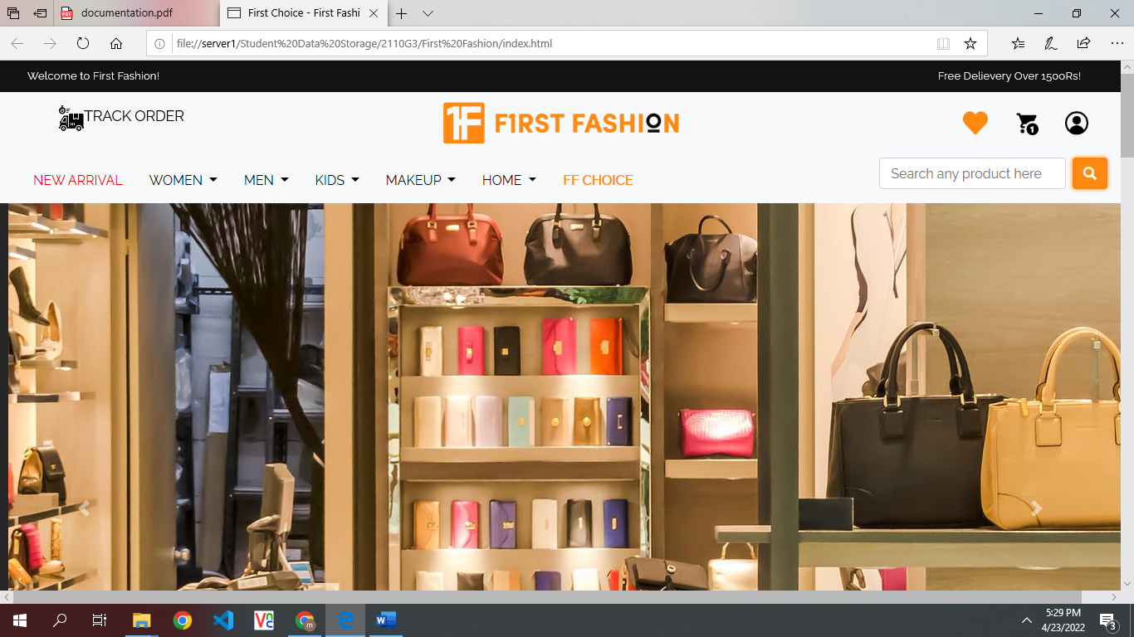

# *Figure 1: Home page to FIRST FASHION:*

First Fashion is a famous reseller Fashion Brand having slogan of “First Choice” Means People Love Quality of our product even on their first choice. The Home Page Consist of all categories sections with their respective images!

* **Navbar (index.html)**



***Figure 2: Navbar***

We have given seven pages. By clicking any of the page and redirect to the linked page.

.

**Description Of our Navbar**

There is a unique navbar which is greeting welcome at top of the page with free delivery news. In 2nd line there is a main logo at center and on left there is track order Icon which redirect you to track-order. html and on right side you have 3 icons of heart (redirects to favorites.html), Cart, and User icon (redirect you to sign-in.html).

In third line of nav-bar there are seven products, which are:

* New Arrivals (***All new items in our website are listed in new arrivals also***)
* Women’s (In our women’s page we have seven categories, listed below:

1. ***KURTI***
2. ***WESTERN***
3. ***JEWELLERY***
4. ***SHAWLS***
5. ***BAGS***
6. ***FOOTWEARS***
7. ***WATCHES***

* Men (In our men’s page we have five categories, listed below:

1. ***KURTA***
2. ***WESTERN***
3. ***WASTCOAT***
4. ***FOOTWEAR***
5. ***WATCHES***

* Kids (In our Kid’s page we have five categories, listed below:

1. ***CLOTHES***
2. ***SHORTS***
3. ***WATCHES***
4. ***FOOTWEAR***
5. ***TOYS***

* Makeup (In our Makeup’s page we have four categories, listed below:

1. ***LIPSTICK***
2. ***EYESHADE***
3. ***EYELINER***
4. ***MAKEUP-KIT***

* Home (In our Home page we have four categories, listed below:

1. ***BEDSHEETS***
2. ***CUTAINS***
3. ***CARPET***
4. ***RUG***

* FF choice (***In this page exclusive FF editor choices are listed***)

## 2.About us (about.html)

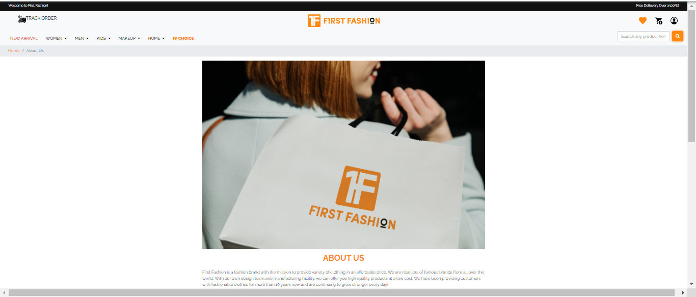

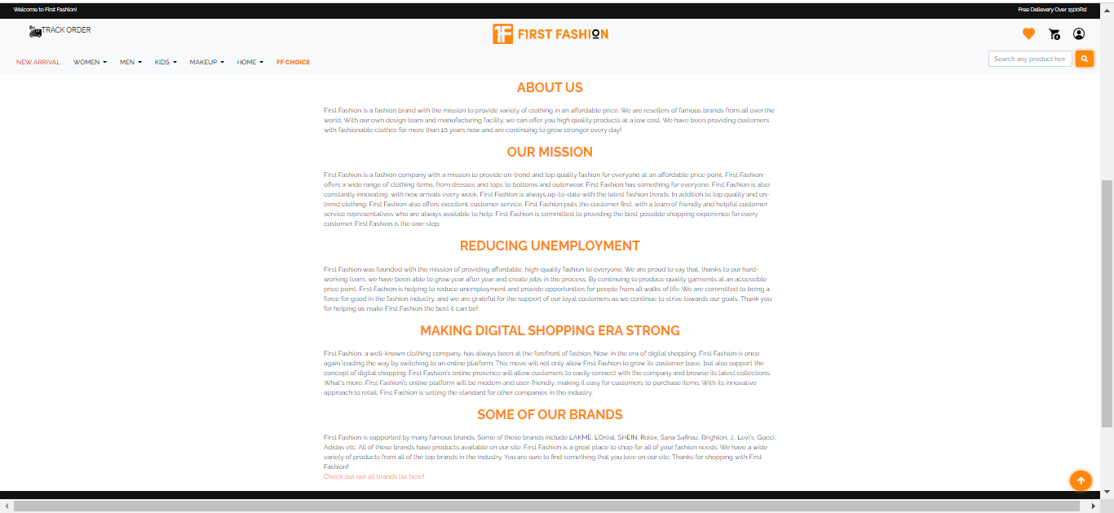

***TERMS & CONDITION’S :***

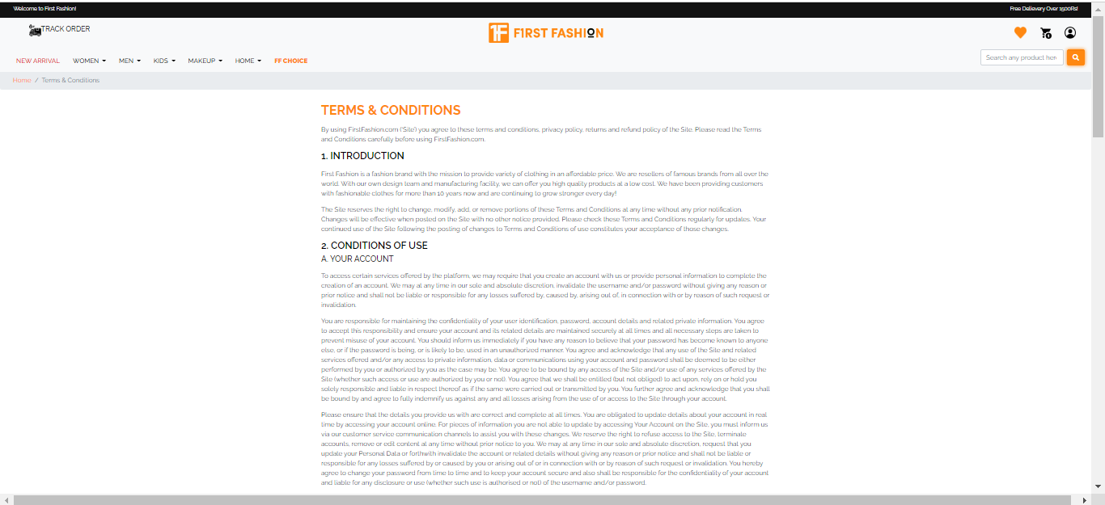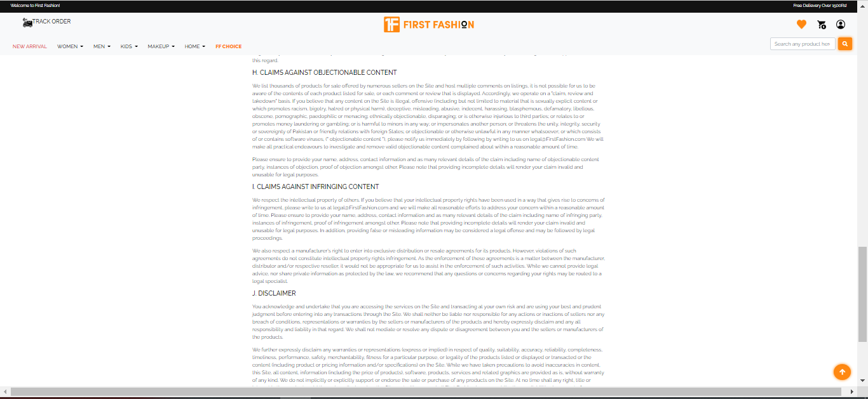

## 2.Footer(index.html)

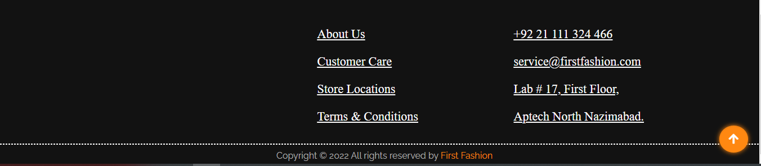

• The footer is separated into four grids: the first grid shows the about, which allows people to contact us for additional information; the second grid shows the customer care, which allows individuals to mail us for their orders; the third grid shows the store location, and fourth grid shows terms and conditions of our page.

**2.****About us (about.html)**





***CONTACT PAGE:***(customer_care).html

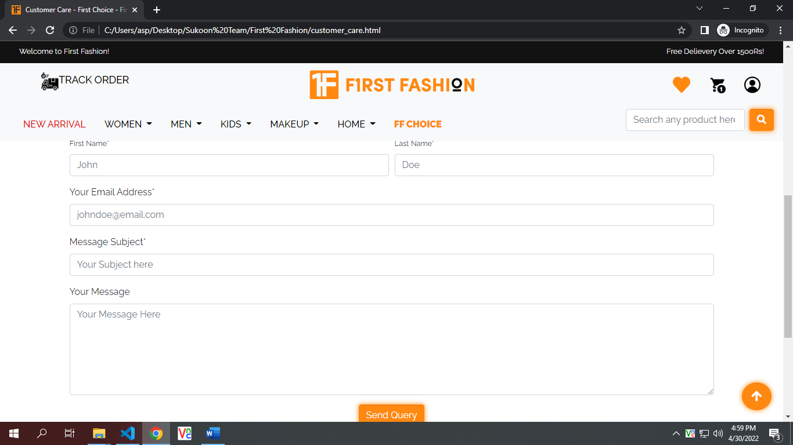

***STORE LOCATIONS PAGE:***(store_locations).html

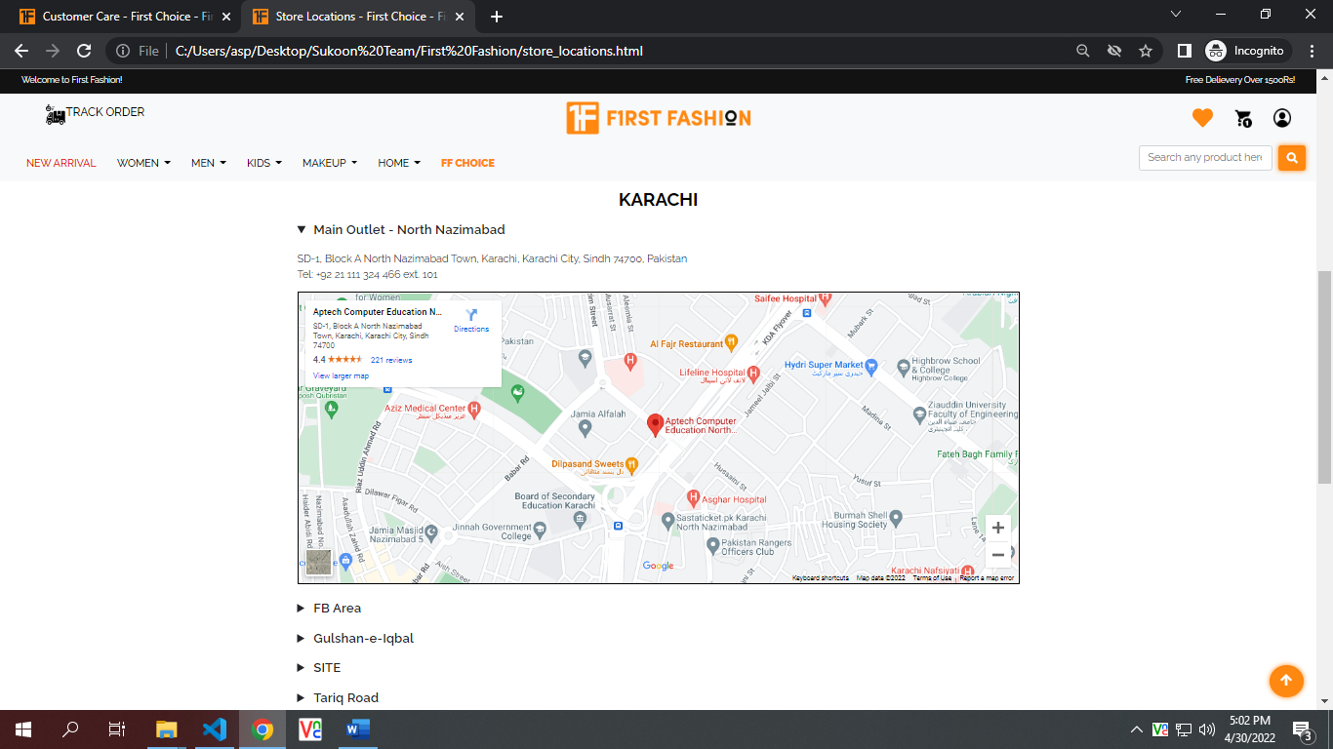

***SIGN IN PAGE:***(SIGN-IN).html

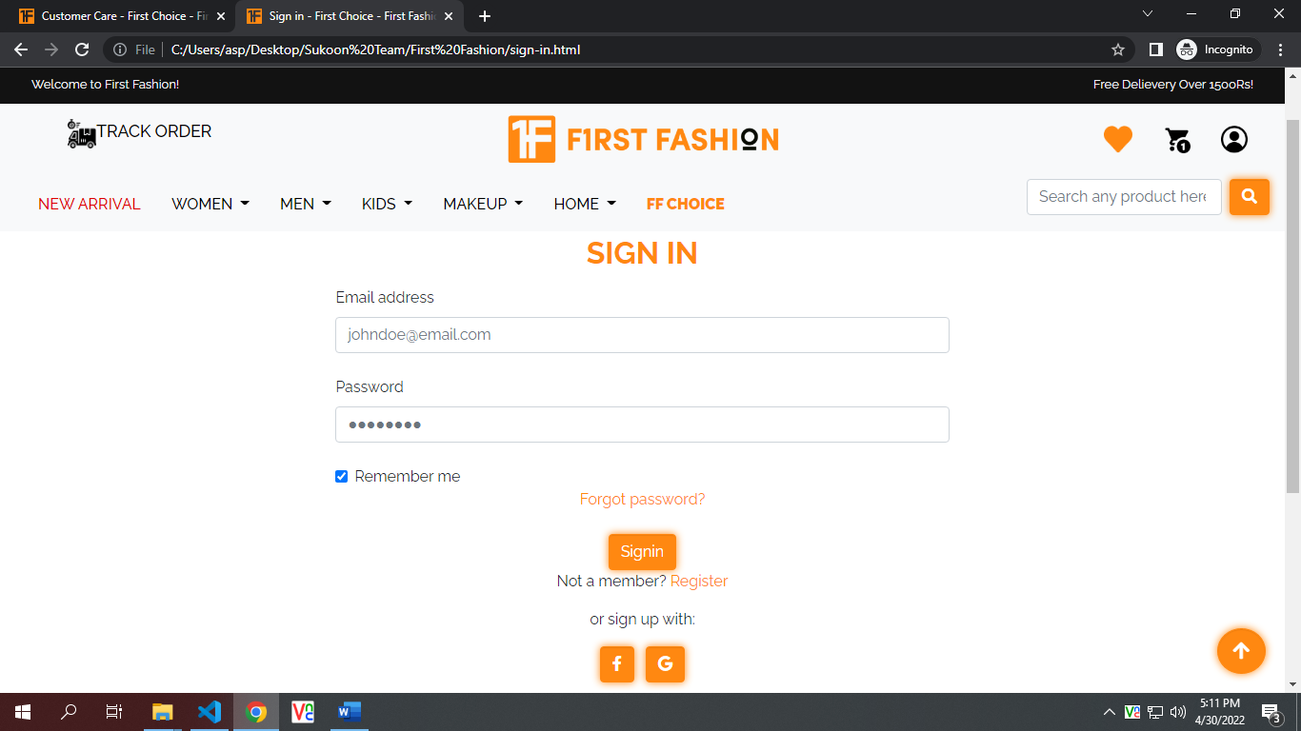

Sign in page and reegister now and forgot password is completed and also data validation and some other jave script is utilized here for good results.

***REGISTER NOW PAGE:***(register-now).html

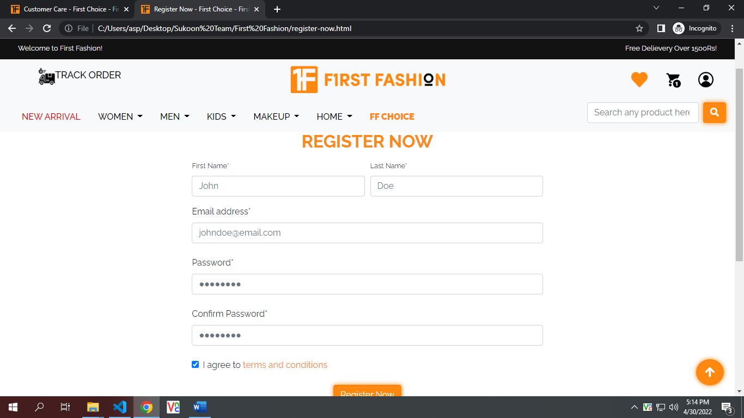

***TRACK ORDER PAGE:***(track_order).html

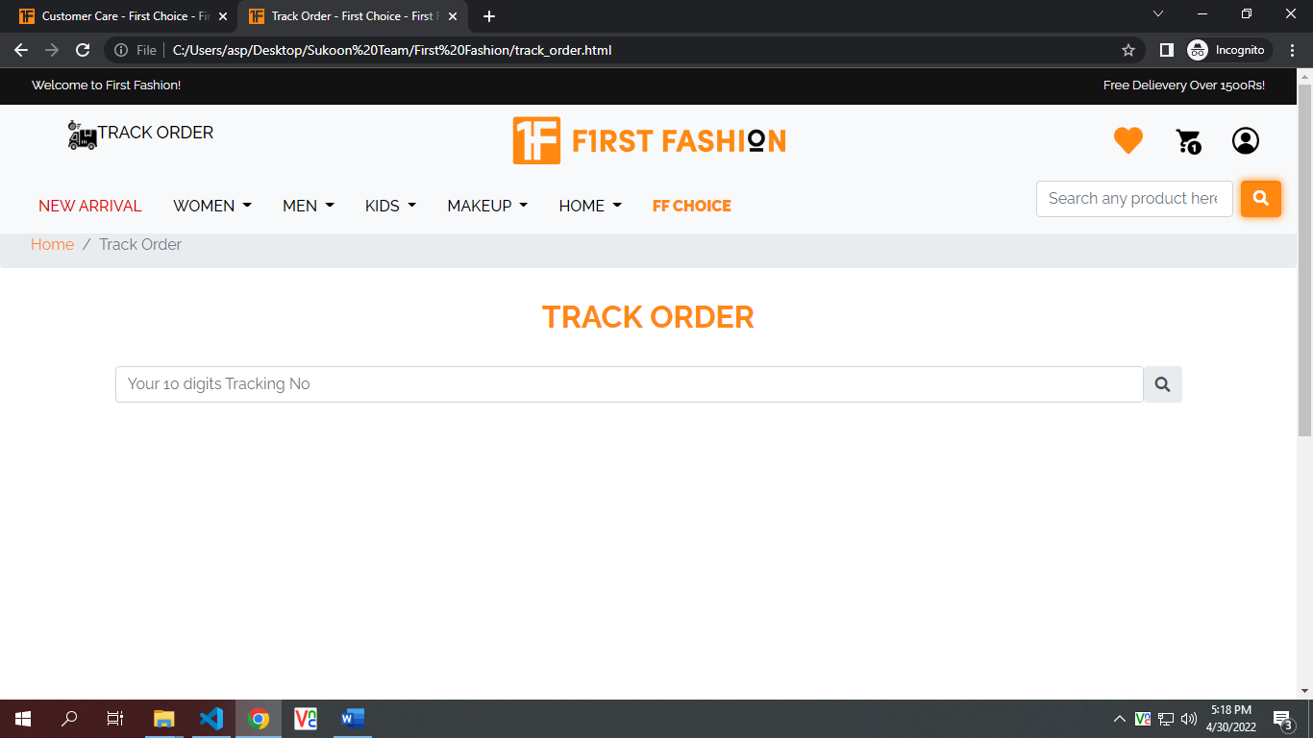

***PRODUCTS PAGES:***

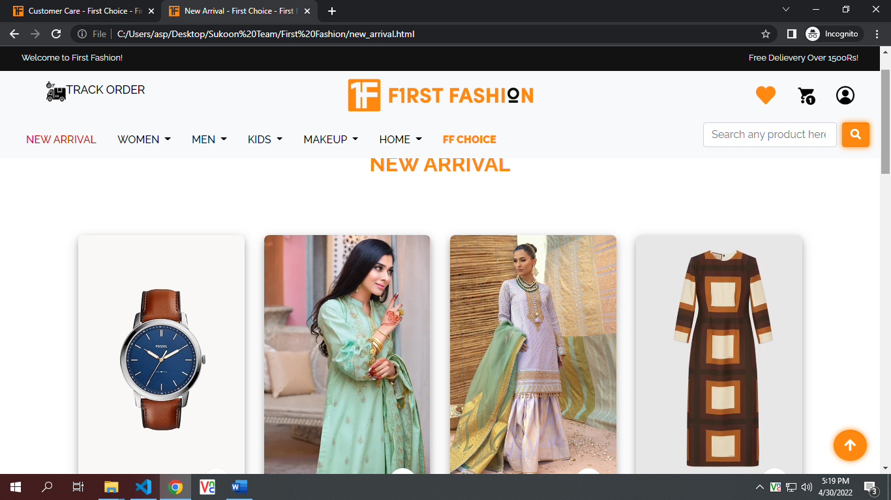

***CATEGORIES PAGES:***

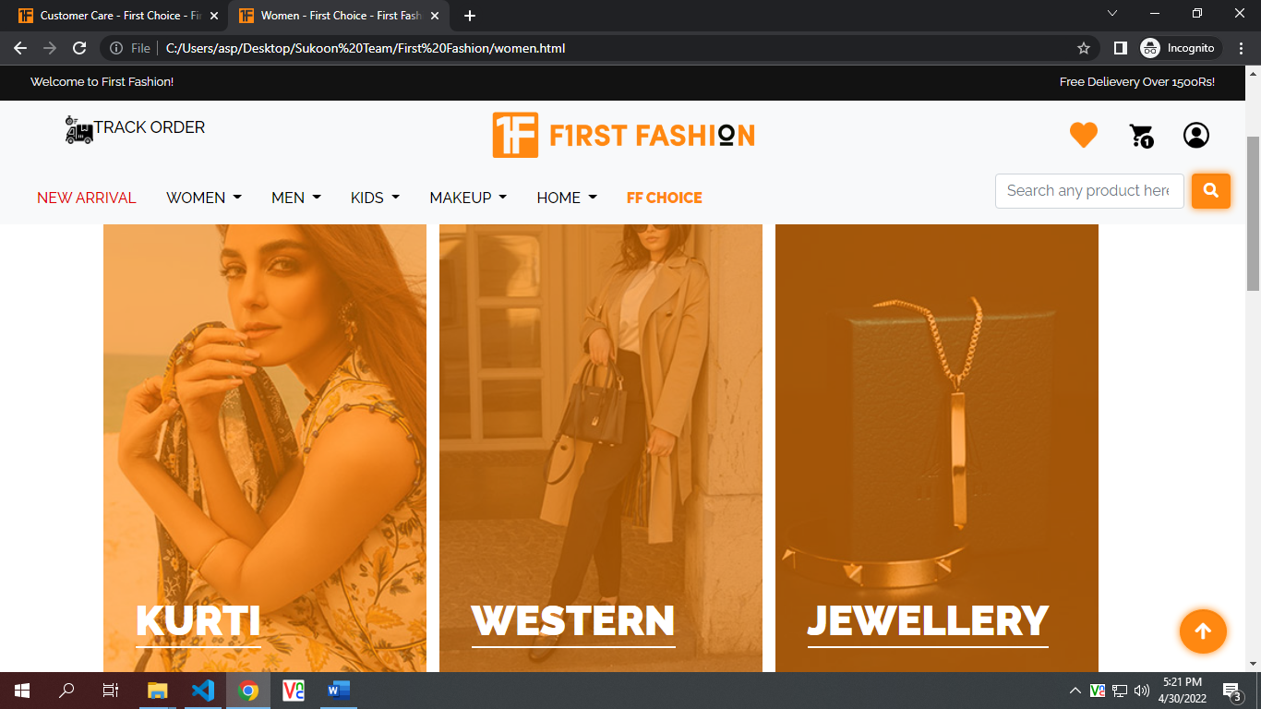

***PRODUCTS DETAIL PAGES:***

